

**Assignment Of**

**Web-System & Tech (CSS Tasks)**

**Task 1 To 33**

**Submitted To:**

**Sir.Zeeshan Bhatti**

**Professor Dept:**

**Information Technology**

**Submitted By:**

**Mubashir Ali S/O**

**Mansoor Ali**

**(2k20/ITE/73) Group(A)**

**Exercise 1:Using Inline Style In This Task You Will Create An HTML Page, And Apply CSS Style Inline To Different Elements On The Page Using The Element's Style Attribute. The Output Should Look As Shown In The Figure Below:**

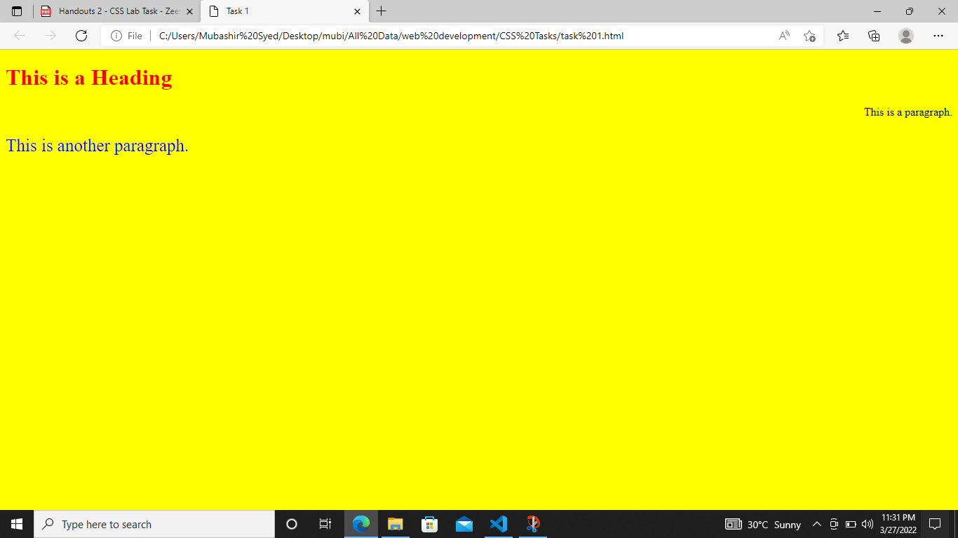

**Exercise 2:Using Internal Style Sheet In This Task You Will Create An Html Page, And Apply Css Style Within The <Style> Element, Inside The <Head> Section Of An Html Page. The Output Should Look As Shown In The Figure Below:**

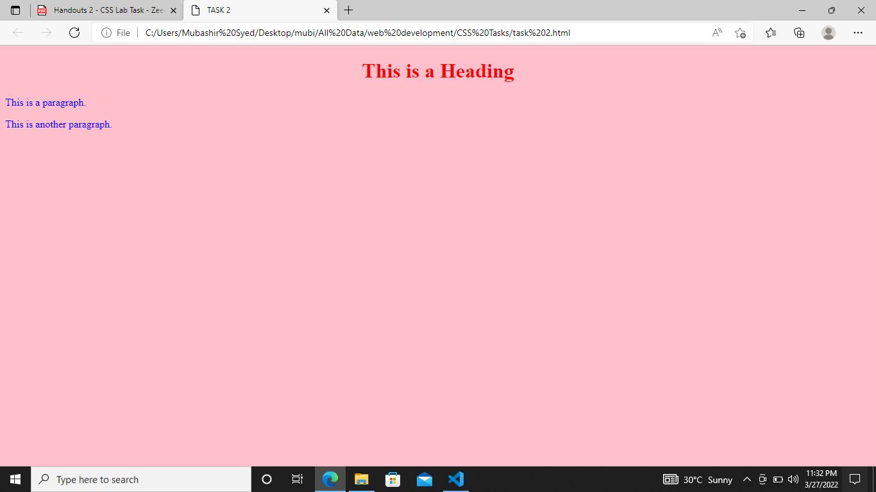

**Exercise 3:Using Css Set The Background Color Of H1, H2, P, And Body Tags.**

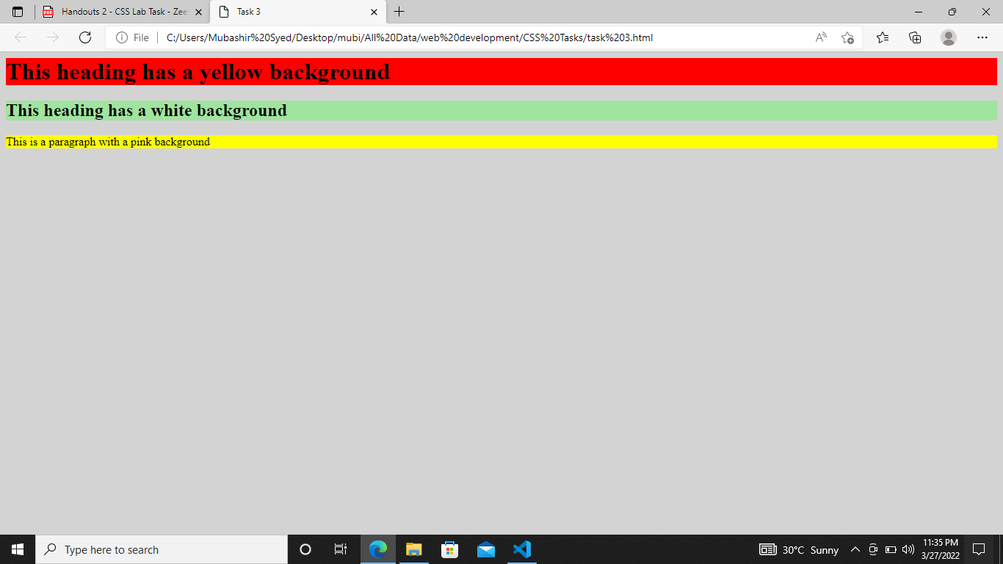

**Exercise 4: Using Css Set A Background Image For A Page.**

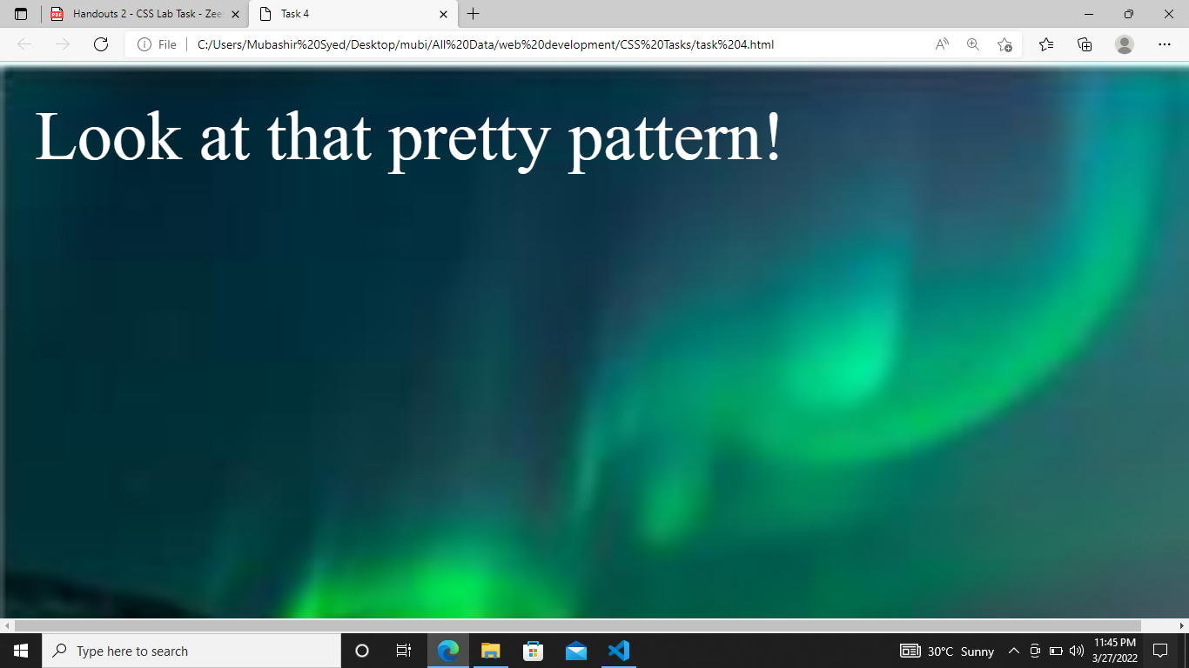

**Exercise 5: Set A Background Image That Repeats For The Whole Page.**

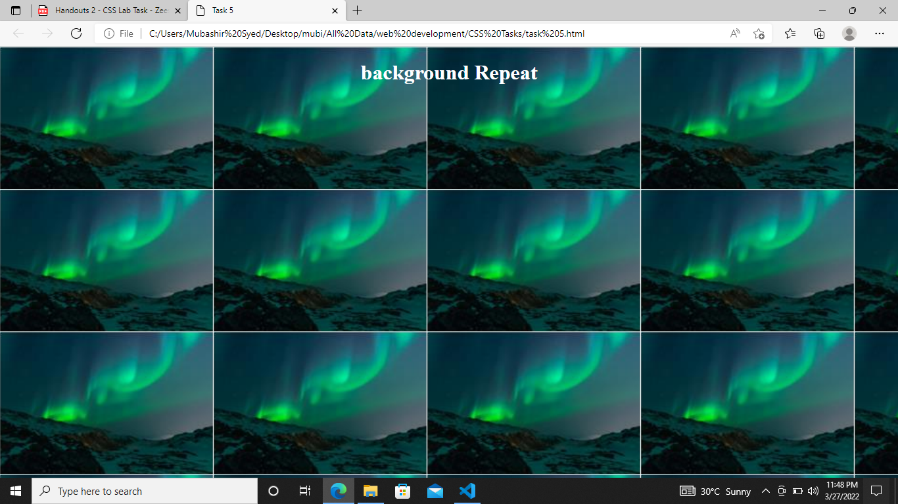

**Exercise 6: Set A Background Image That Is Center Positioned.**

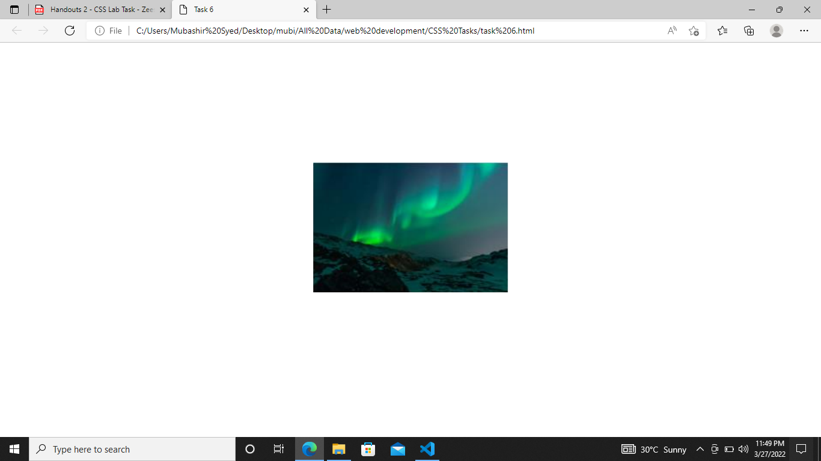

**Exercise 7: Set Different Text Decorations As Shown In Figure.**

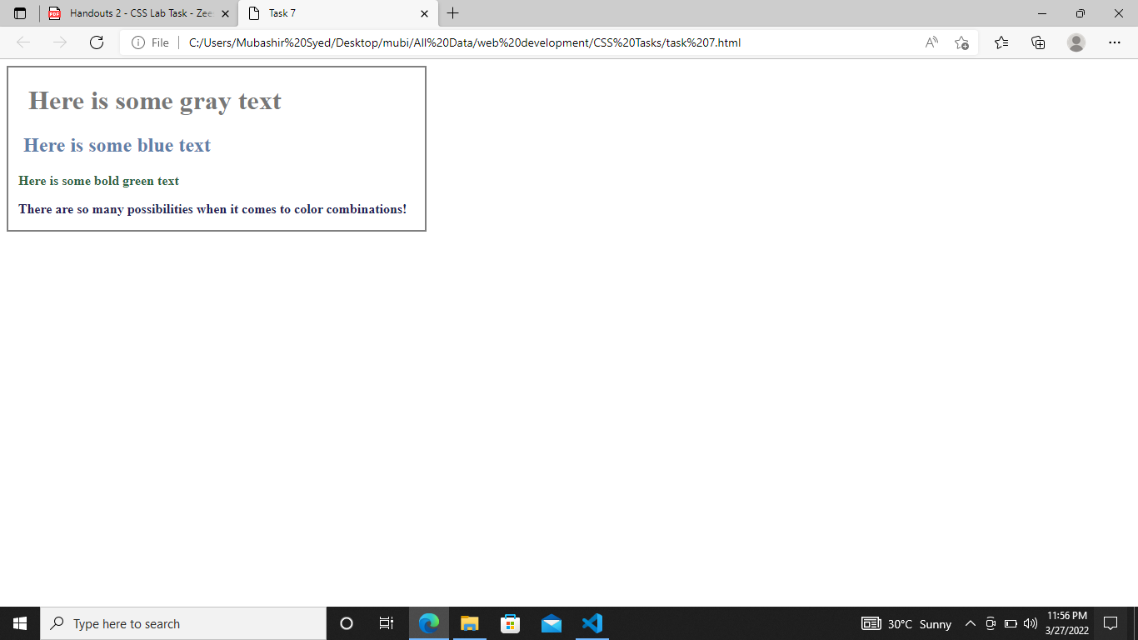

**Exercise 8: Setting Text Background Color.**

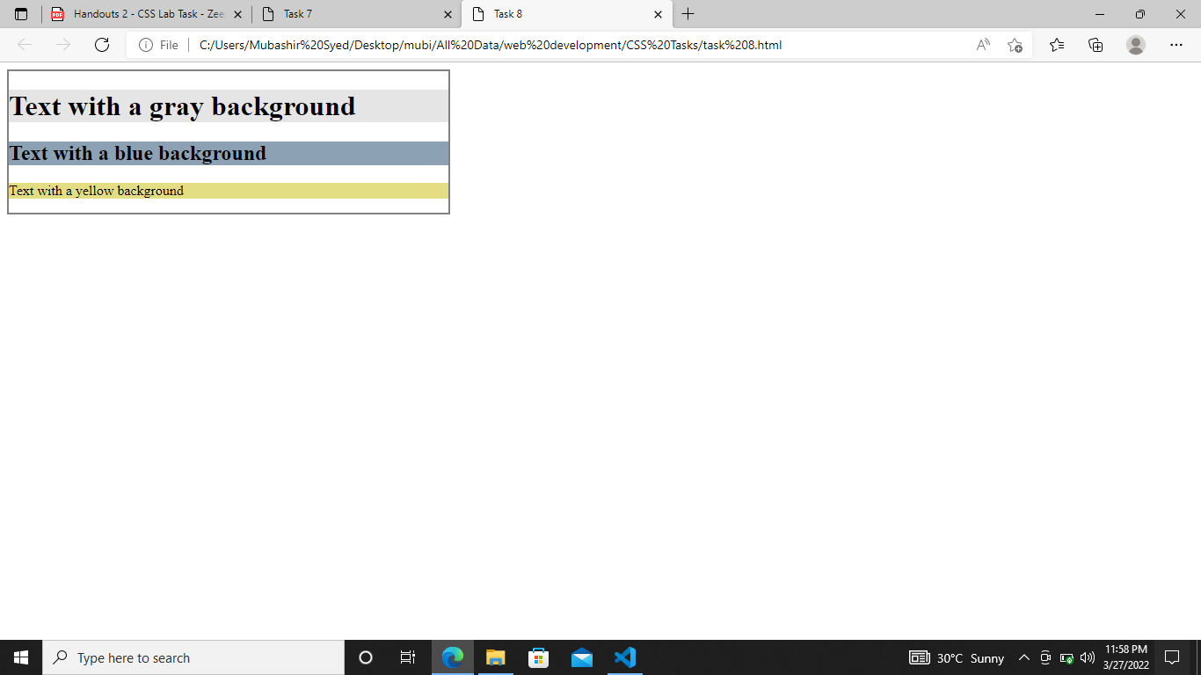

**Exercise 9: Setting Text Decoration.**

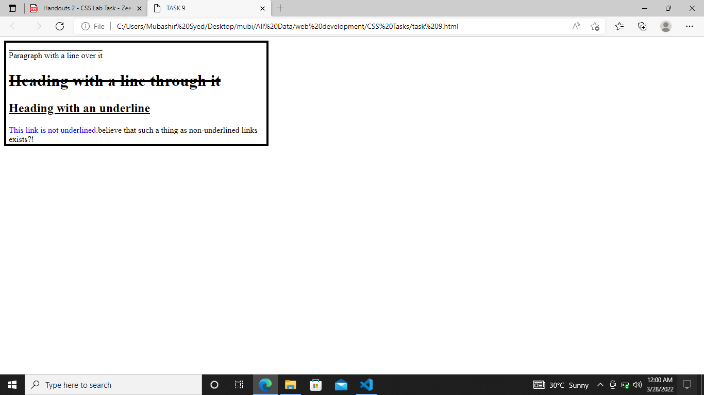

**Exercise 10: Use Css To Change The Font Type Of Text Differently For Each Of The Heading Tags From H1 To H6. All Heading Tags Must Have Different Font.**

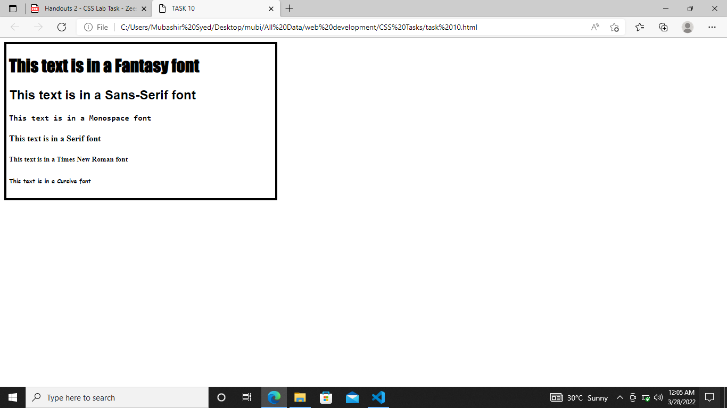

**Exercise 11: Use Css To Create Unordered Lists With Different Bullets.**

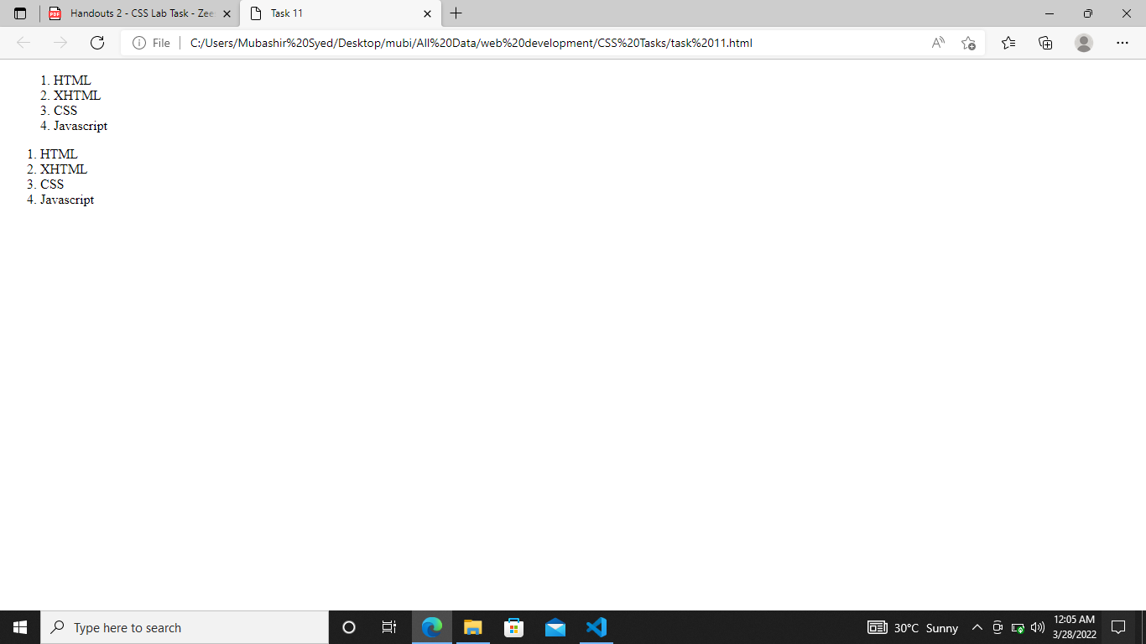

**Exercise 12: Use Css To Create Ordered Lists With Different Bullets.**

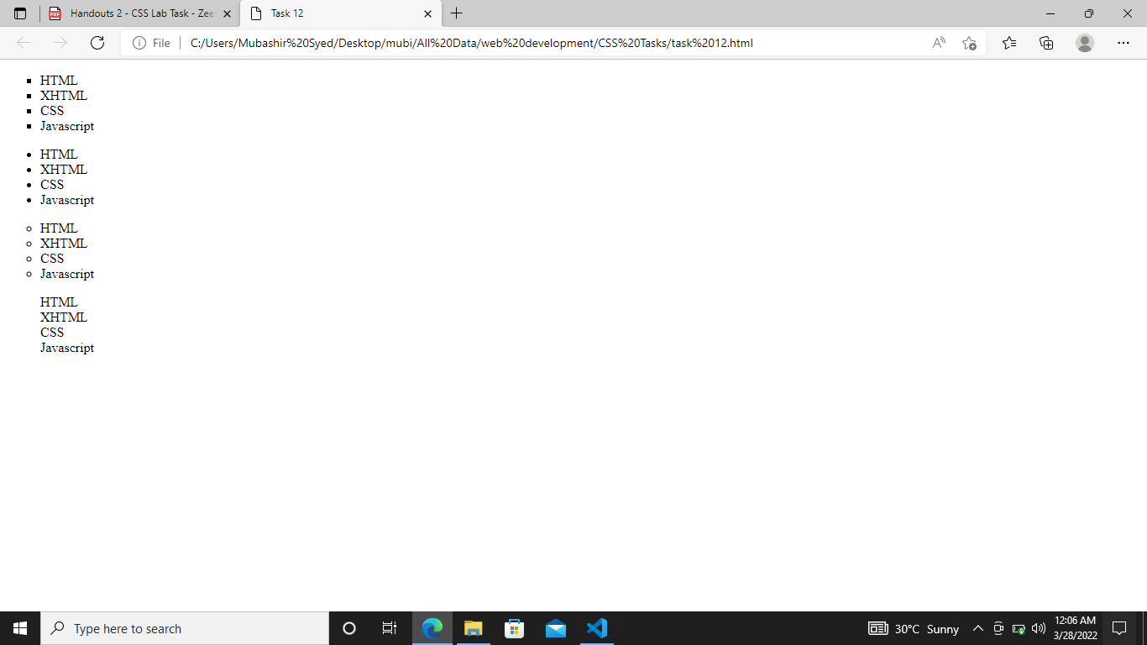

**Exercise 13: Use Css To Create A List Using An Image For Bullets In A List.**

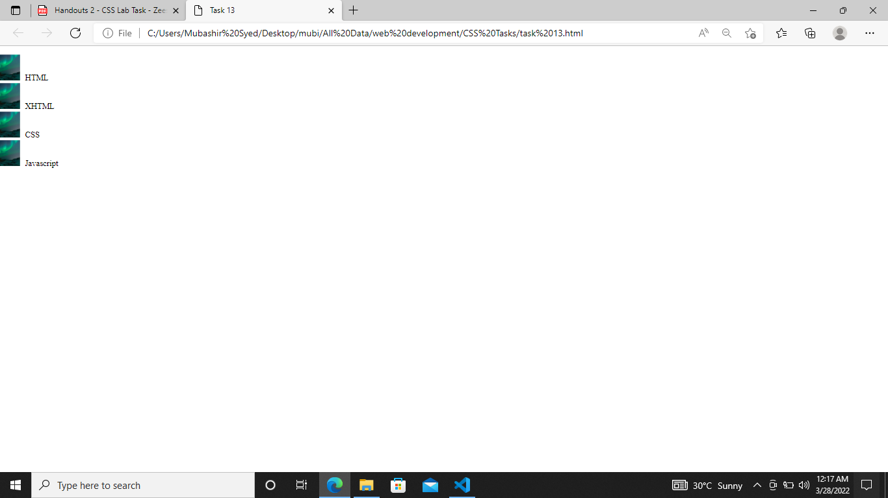

**Exercise 14: Use Css To Set Styles Of The Left, Right, Top And Bottom Boarder.**

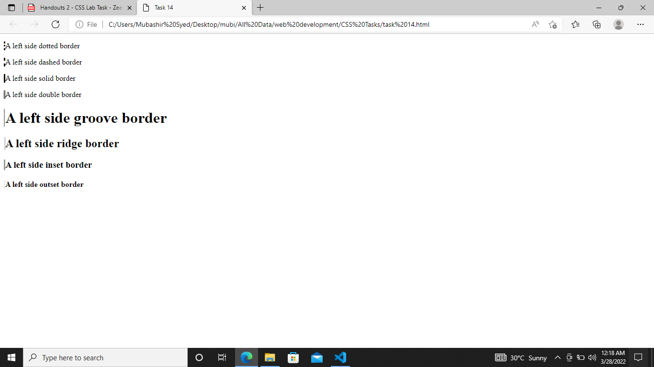

**Exercise 15 : Change The Indentation Of The Left , Right , Top Margins Using Css.**

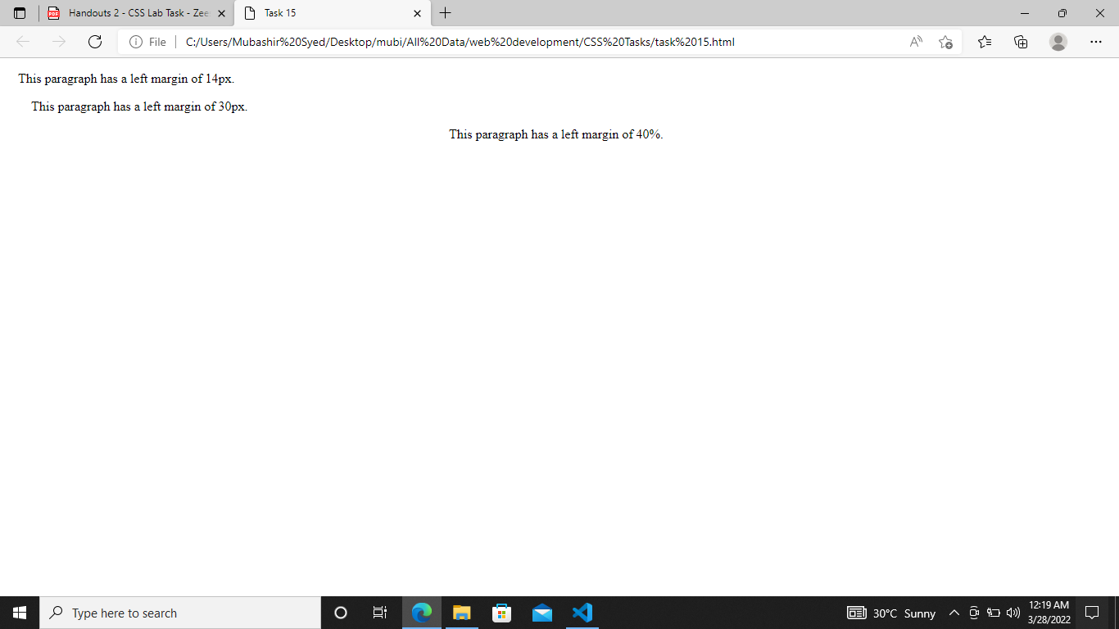

**Exercise 16 : What Will Be The Output Of The Following Code.**

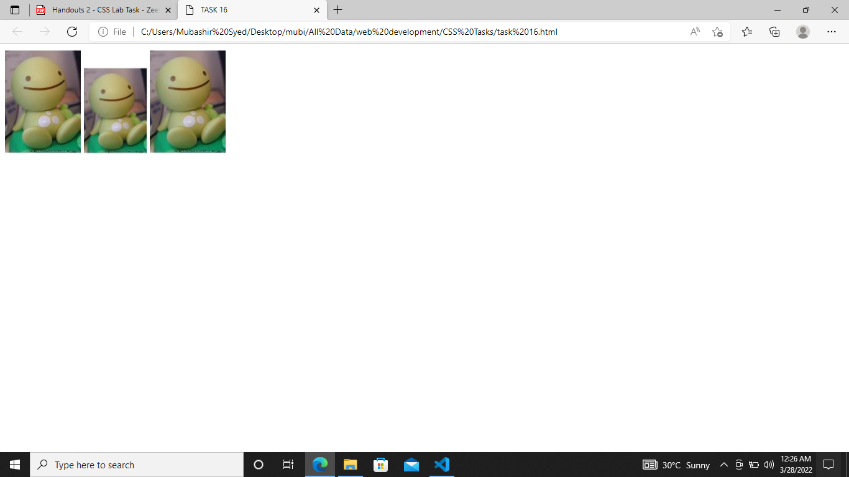

**Exercise 17 : Set Different Margins For All Four Sides Of A <P> Element As Shown In Code Below And Apply It On A Page.**

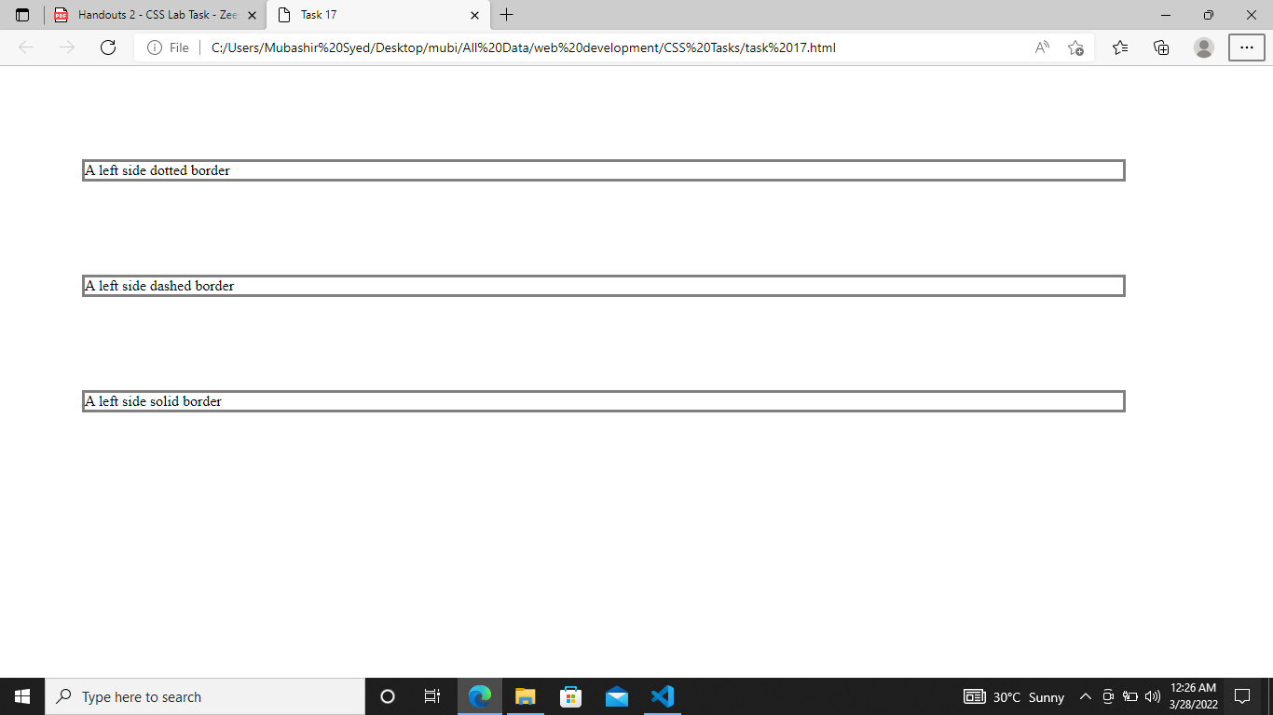

**Exercise 18: Set Different Padding For All Four Sides Of A <Div> Element:**

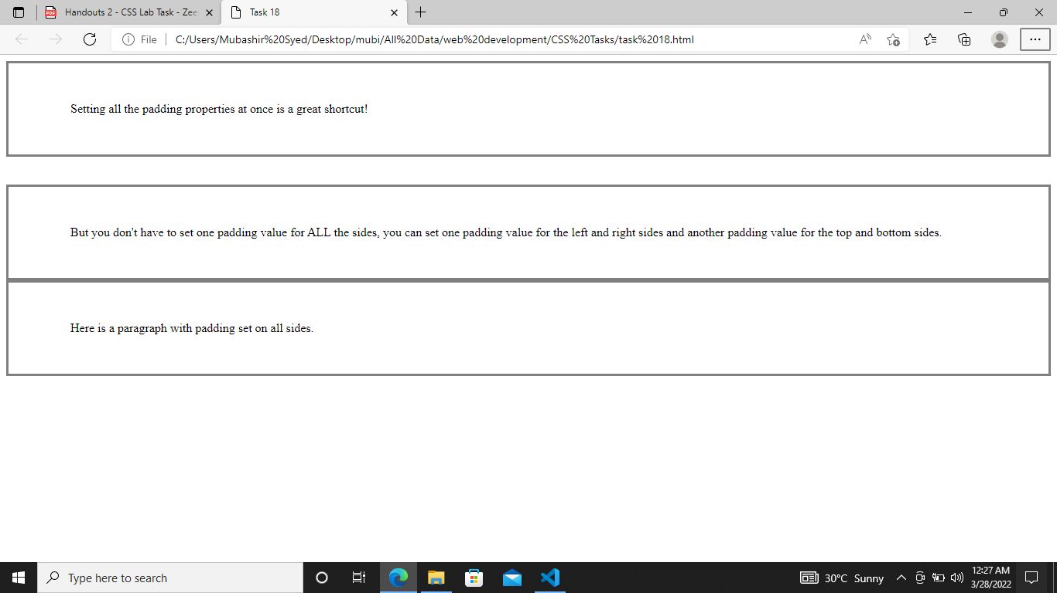

**Exercise 19: Write The Css For Creating A Padding Of Div Tag With Boarder And Background Color As Shown Below.**

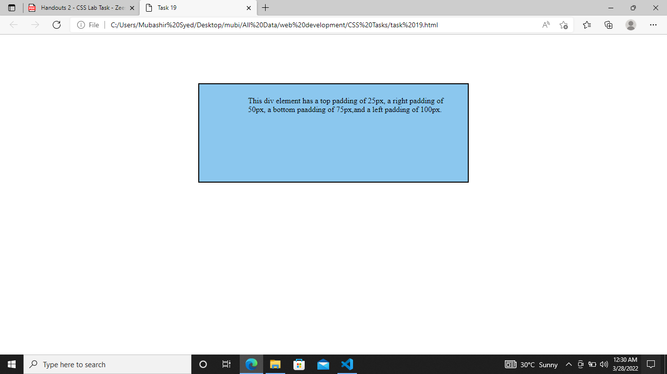

**Exercise 20: Create A Div Element With Height Of 200Pixels, And With Of 50% As Shown Below,**

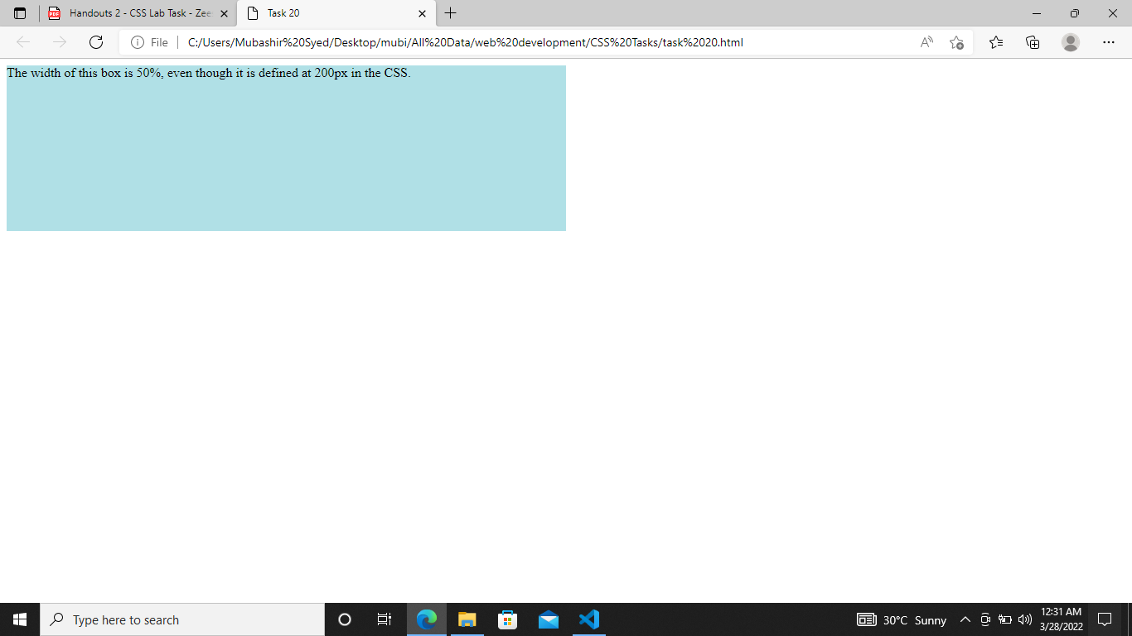

**Exercise 21: The Css Box Model Is Essentially A Box That Wraps Around Every Html Element. It Consists Of: Borders, Padding, Margins, And The Actual Content. Create A Box With Following Specifications**

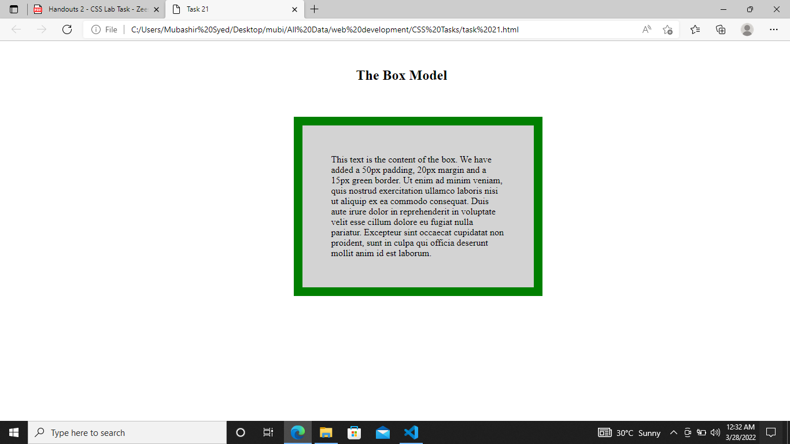

**Exercise 22: An Outline Is A Line That Is Drawn Around Elements, Outside The Borders, To Make The Element "Stand Out".**

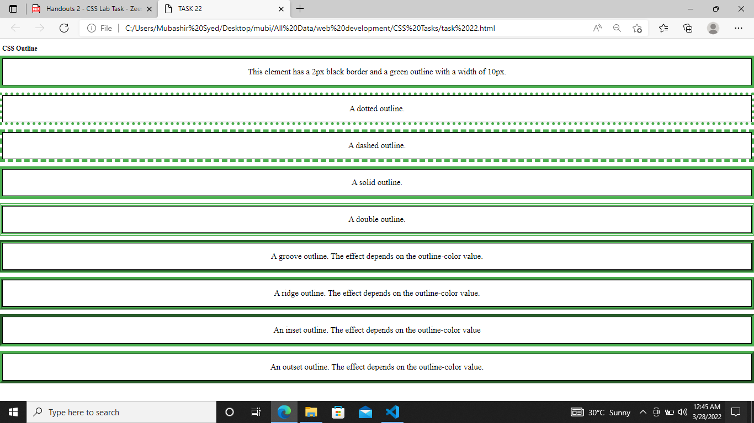

**Exercise 23: Add Various Different Icons In Your Webpage Using Bootstrap Icons With Following Code.**

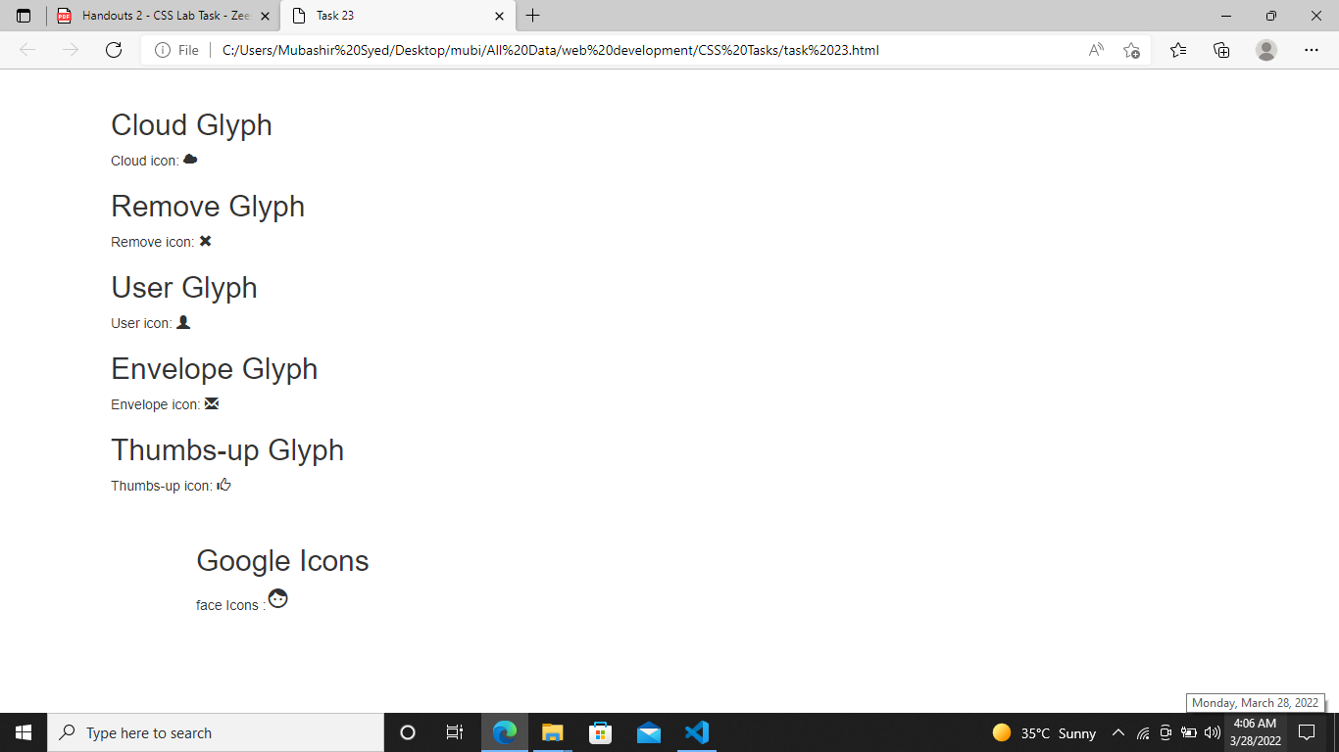

**Exercise 24: Use The Following Link States On Your Custom Link.**

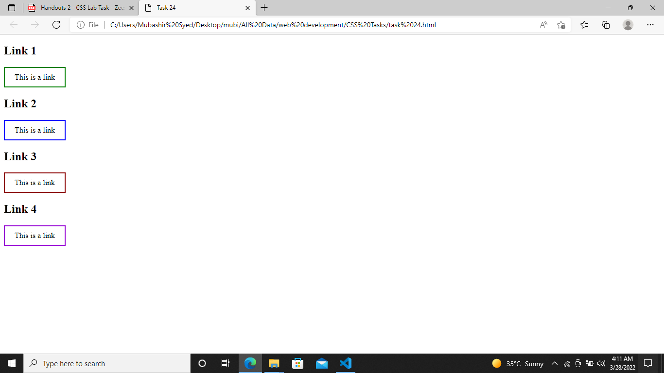

**Exercise 25: Use The Css With Div Tog To Create Following Image Gallery Layout With Boarder .**

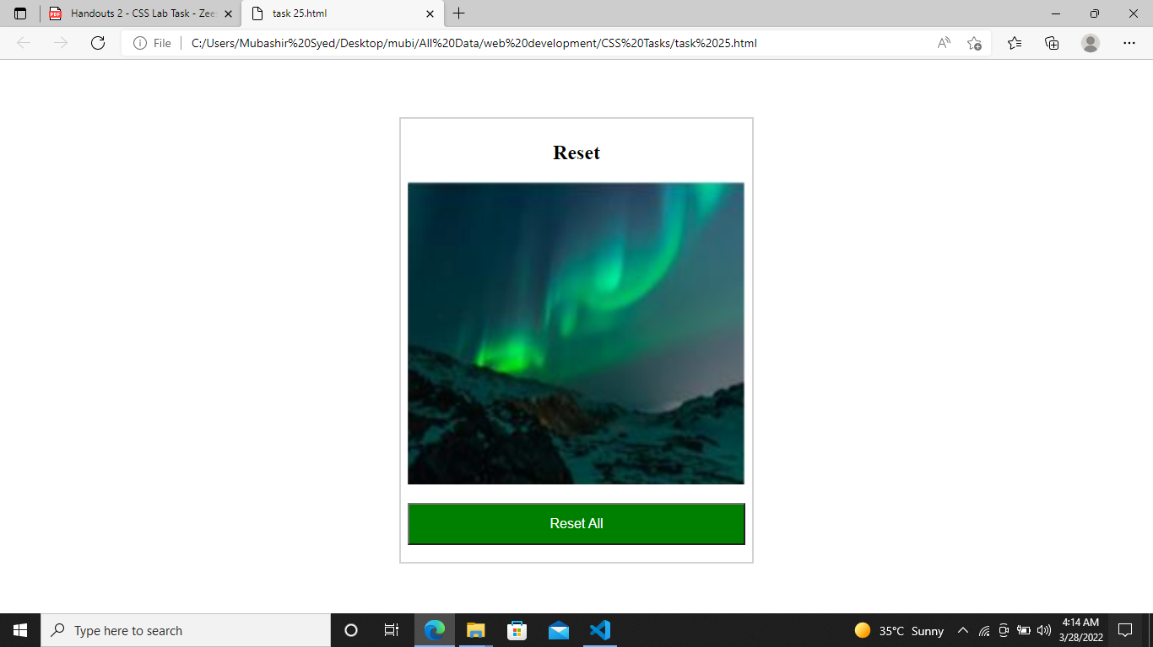

**Exercise 26: Use The Position Property To Set The Position Of Each Div Tag.**

**The Position Property Specifies The Type Of Positioning Method Used For An Element.There Are Five Different Position Values:**

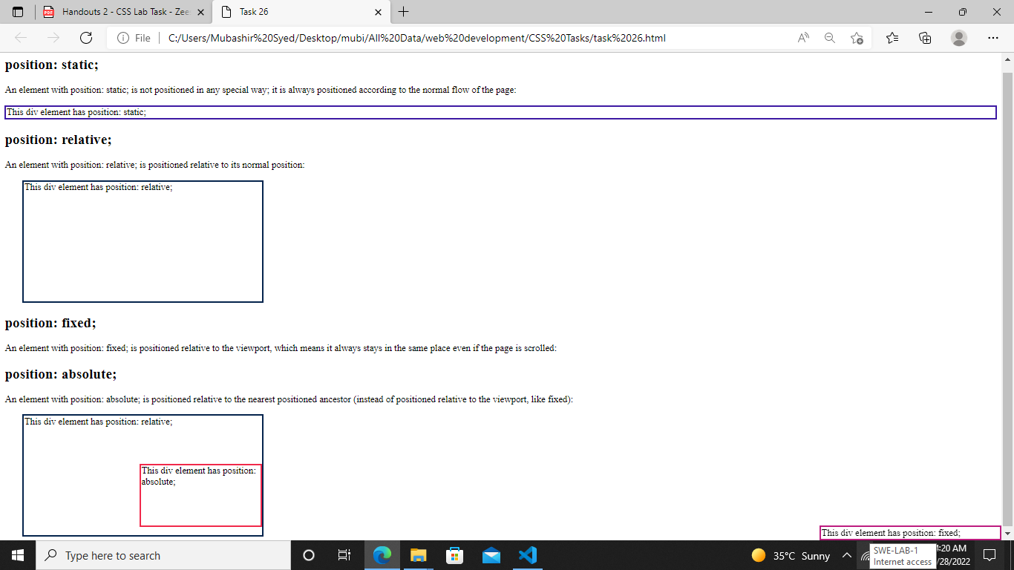

**Exercise 27:An Element With Position: Sticky; Is Positioned Based On The User'S Scroll Position.A Sticky Element Toggles Between Relative And Fixed, Depending On The Scroll Position. It Is Positioned Relative Until A Given Offset Position Is Met In The Viewport - Then It "Sticks" In Place (Like Position:Fixed).**

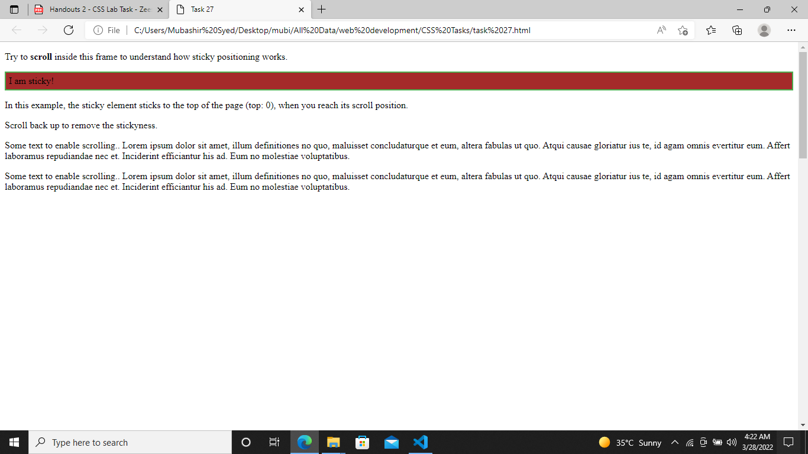

**Exercise 28: Use The Css To Create A Horizontal And Vertical Navigation Bar As Shown In Figure.**

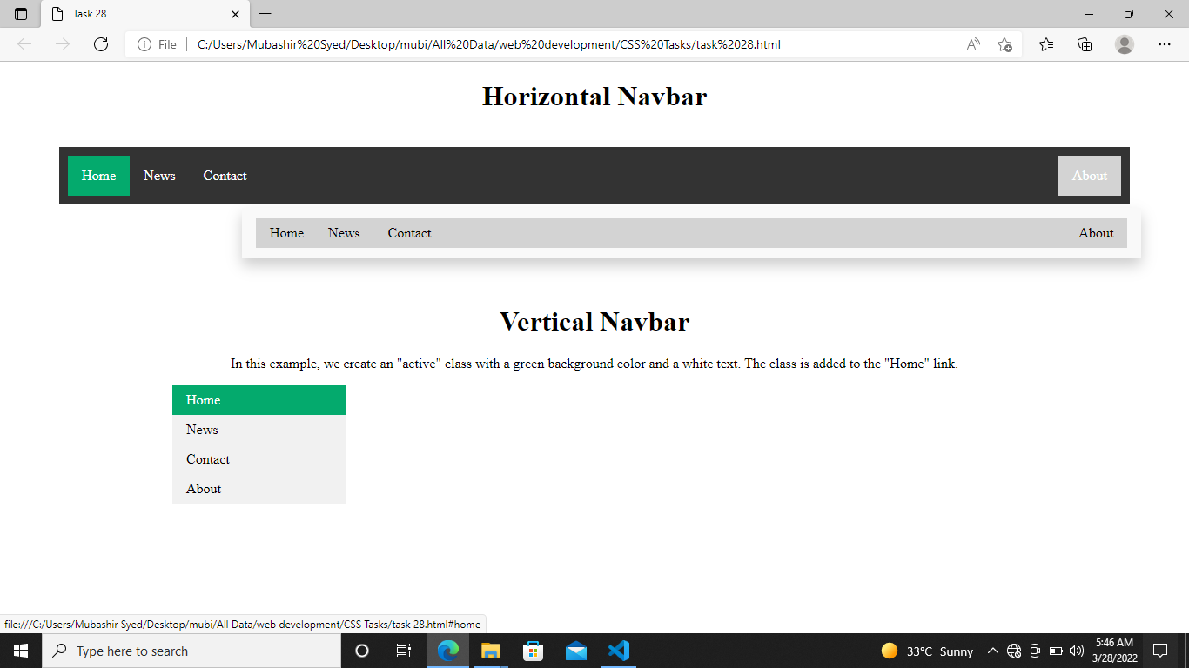

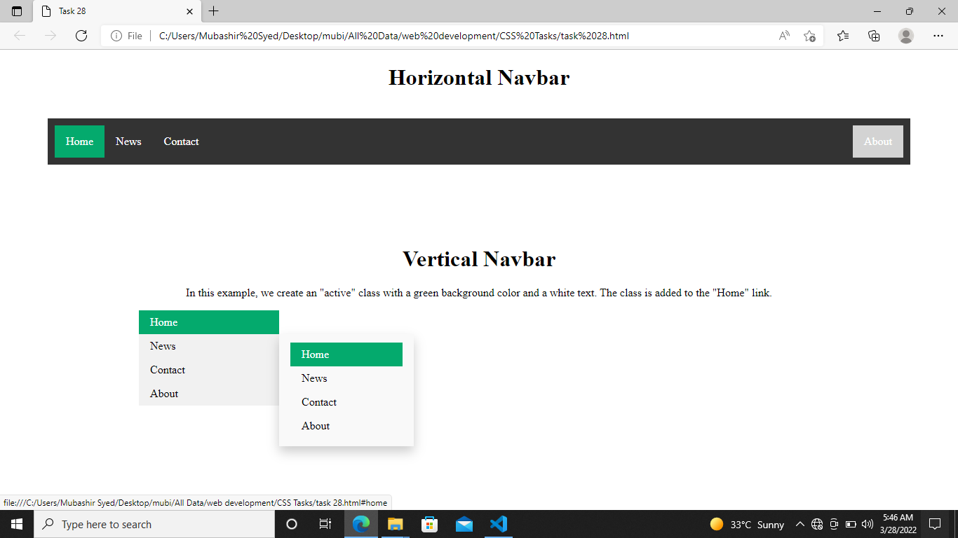

**Exercise 29: Create A Navigation Menu That Occupy Full Left Side Of Screed, With Full Height, Sticky Navigation Menue.**

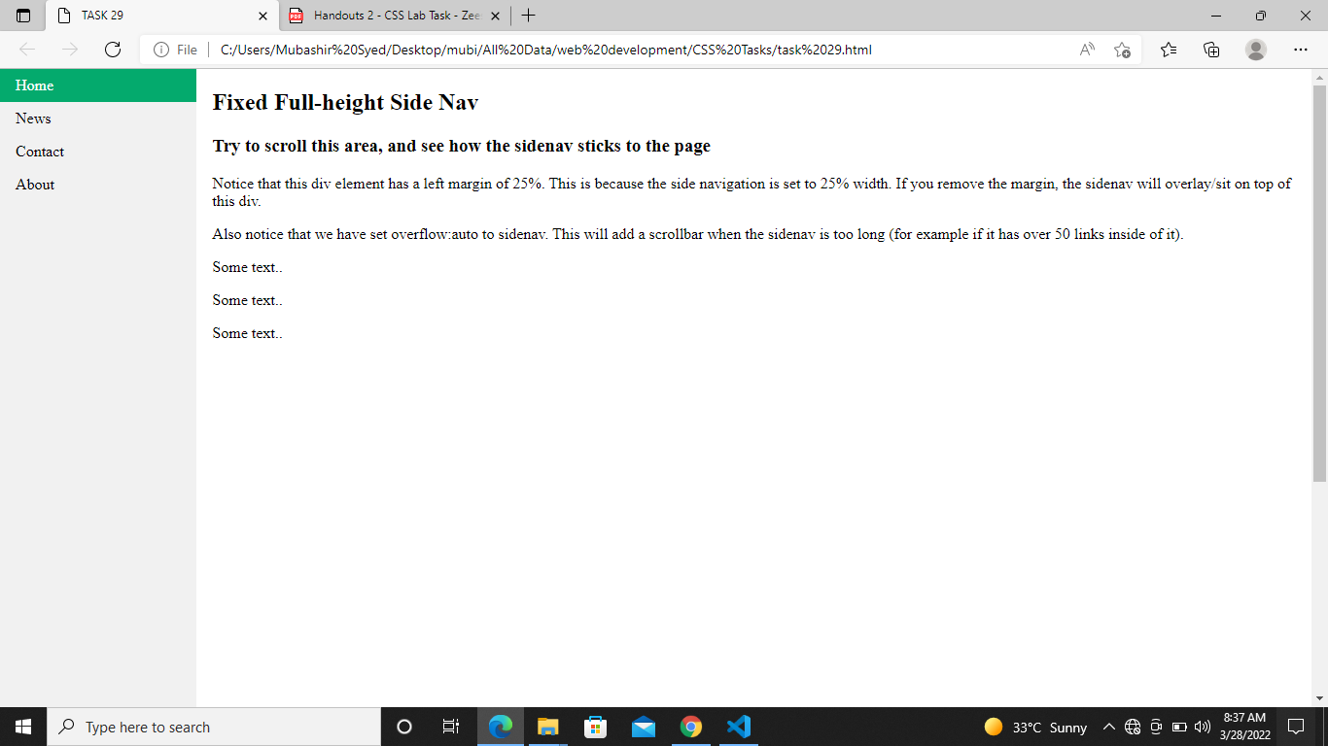

**Exercise 30: Create A Simple Horizontal Navigation Menue As Shown Below**

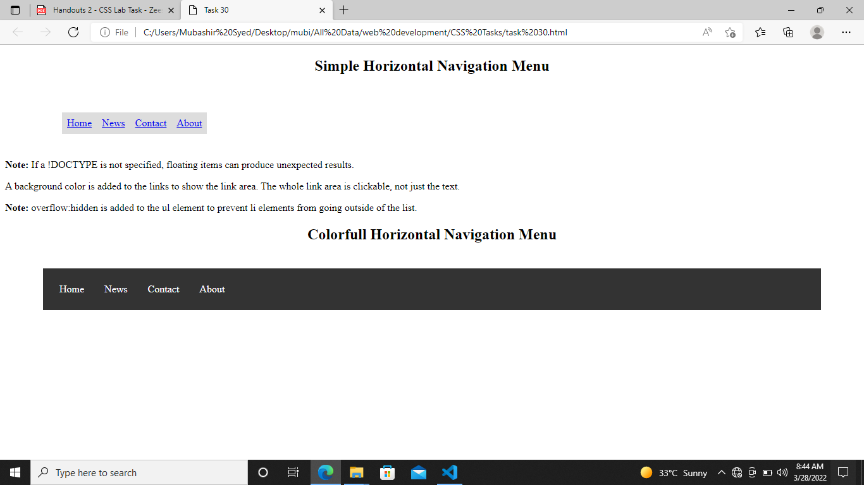

**Exercise 31: Create A Dropdown Navigation Menu**

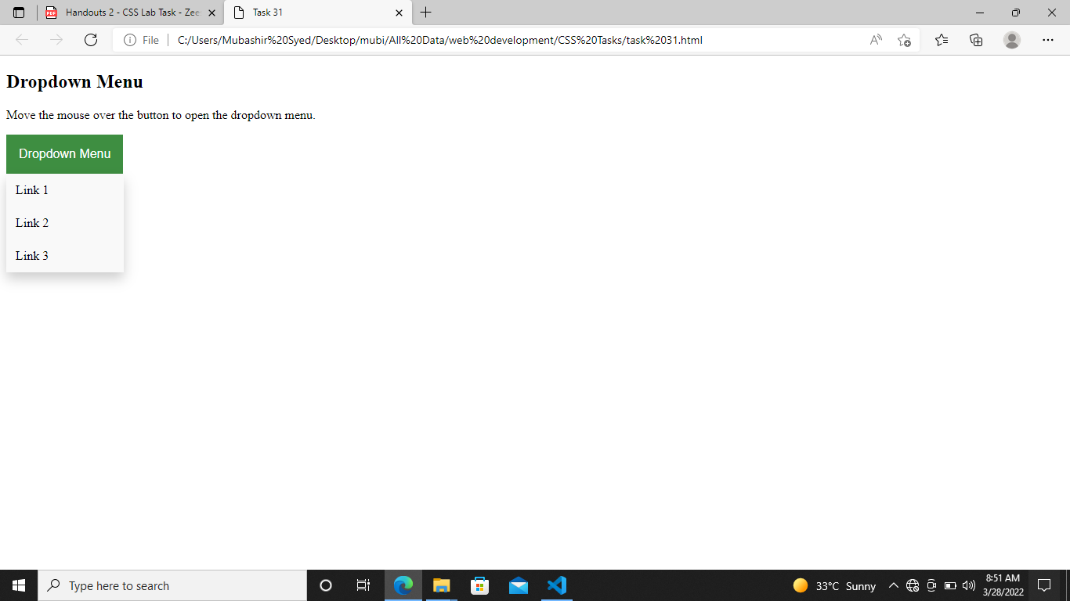

**Exercise 32: Create A Image Gallery With Multiple Thumbnails As Shown**

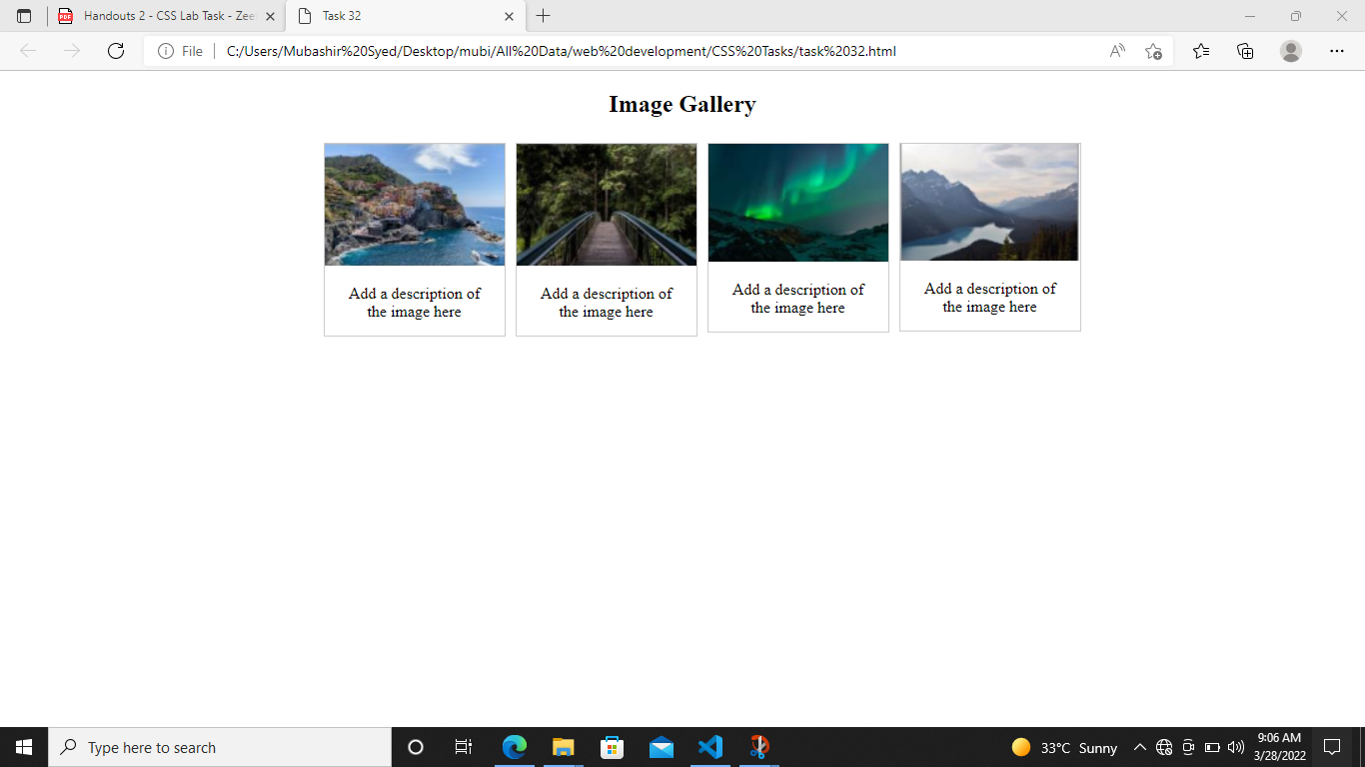

**Exercise 33: Create A Website Layout Using Css And Div Tags As Shown In Figure Below. The Style Sheet Is Also Given, Add The Relevant Div Tags In Html.**

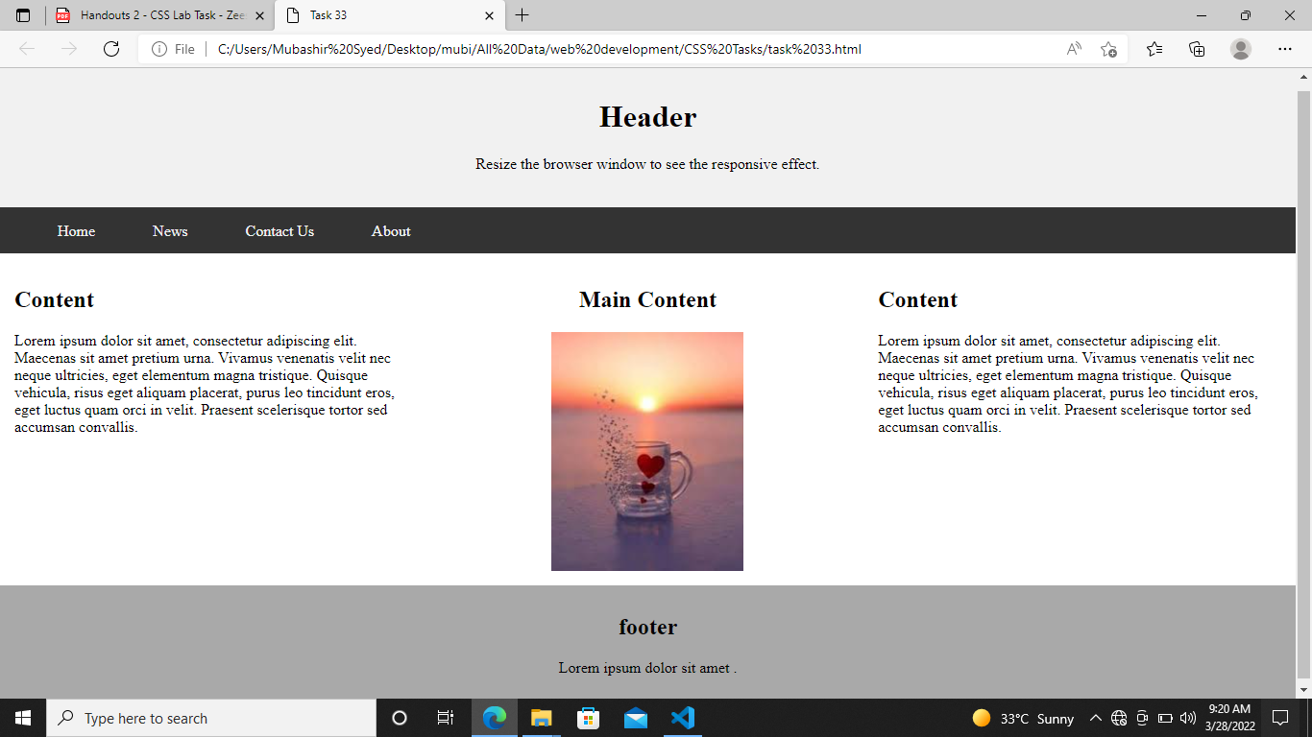

**The End**